**Jurnal Kesehatan Komunitas Indonesia (JKKI)**

Citation count: 165

https://ebsina.or.id/journals/index.php/jkki

eISSN 2503-2801, pISSN 2985-3435

**Overall Top 10 Most Influential Mental Health Factors for Generation Z (Globally)**

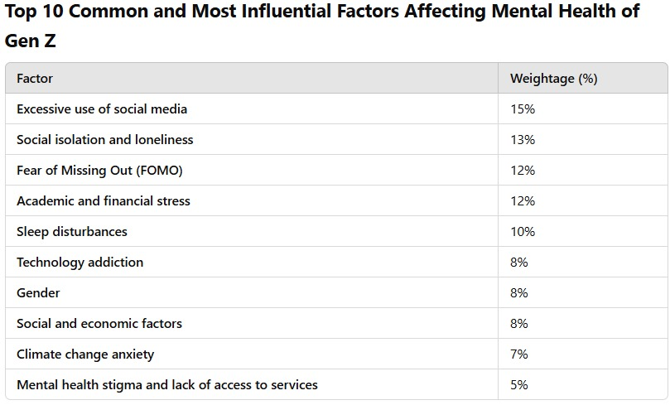

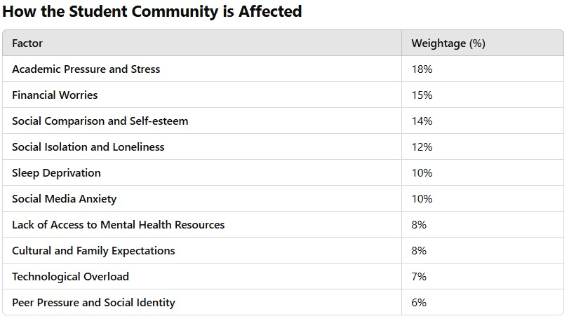

**Conclusion:**

In the current global scenario, the topmost influential factors affecting the mental health of Generation Z, when considered across all six continents, are:

* Excessive use of social media
* Social isolation and loneliness
* Fear of Missing Out (FOMO)
* Academic and financial stress
* Sleep disturbances

These factors are most consistently identified in the research across the continents, showing that social media and digital life are major contributors to mental health issues for Generation Z worldwide.